Sequestration for Managing Carbon

Brandon C. Nuttall, Kentucky Geological Survey, bnuttall@uky.edu
Carbon dioxide (CO₂) is a natural part of Earth’s atmosphere that is essential to life. Climate change and energy issues are serving to focus scientific, public, media, and political attention on the fate of CO₂ emitted as the result of burning fossil fuels. According to 2004 data (U.S. EPA), United States CO₂ emissions from all sources exceeded 5.9 billion metric tonnes (113 trillion cubic feet). In Kentucky, more than 150 million metric tonnes of CO₂ were emitted from all sources including 87 million tonnes from power plants and 34 million tonnes from cars and trucks.
Emissions from the transportation fleet can be mitigated by increasing fuel economy, reducing the number of miles driven, switching to less carbon intensive fuels (natural gas or hydrogen for example), and others. Different technologies are required to manage emissions from large-volume, stationary sources like coal-fired power plants, however. Sequestration, or carbon capture and safe storage (CCS), is an integrated carbon management strategy that includes CO₂ capture, transportation, and underground storage.
Carbon capture for reducing CO₂ emissions can be accomplished either before or after burning fossil fuels. Pre-combustion capture involves reacting coal with steam at high temperature and pressure to produce synthetic gas containing mostly carbon monoxide and hydrogen. The reduced-carbon “syngas” can then be used to fuel integrated gasification combined cycle (IGCC) units for power or used to make liquid fuels, for example the Fischer-Tropsch process to produce diesel fuel. Using chemical solvents can capture the high pressure, CO2-enriched exhaust from this process.
Post-combustion capture requires processing the relatively low concentrations of CO₂ in flue gases. The exhaust gas is processed using chemical sorbants (amines and others) or microporous filters (sieves). Using amines for carbon capture requires heat to regenerate the solvent. Some solvent will be lost because of impurities in the gas and must be replaced. Both pre- and post-combustion carbon capture have an energy penalty; the power required to capture and compress the CO₂ must be generated by the same facility emitting the CO₂. The cost of building new power plants that provide relatively simple and efficient carbon capture must be weighed against the cost of retrofitting older existing conventional combustion units with post-combustion capture facilities.
Once captured, CO₂ will be transported to consumers or to permanent storage. Much of the commercial CO₂ for the beverage industry and others is currently transported as a liquid by truck or rail. The volumes of CO₂ captured at power plants, however, will require pipelines used for decades in the petroleum industry. CO₂ from natural underground sources has been used in west Texas since the 1970’s for enhanced oil recovery in older fields. Almost 2,000 miles of pipeline deliver 1 billion cubic feet of CO₂ per day (53,000 tonnes per day) to Texas oil fields where it is injected to produce an additional 140,000 barrels of oil per day.
Enhanced oil recovery projects differ depending on whether the CO₂ is a gas or a liquid in the underground reservoir. In shallower fields like many in Kentucky that are less than 2,500 feet deep, the CO₂ is a gas that displaces oil much like a piston toward producing wells. In deeper reservoirs, liquid CO₂ interacts with the oil acting as a solvent to change the properties of the oil making it easier to produce. While much of the injected CO₂ remains in the underground reservoir in enhanced recovery projects, some is produced with the oil, captured, and recycled.
CO₂ injection for enhanced gas production has been successfully demonstrated in coal beds. When CO₂ is injected into coal, the coalbed methane (natural gas) is displaced and the CO₂ is preferentially retained. It remains to be demonstrated whether other rocks, like gas shales, exhibit the same potential for enhancing natural gas production.
Calculations indicate that the volume of emitted CO₂ available for capture exceeds the amount that could be used for enhanced recovery nationwide even if CO₂ EOR were implemented in all appropriate reservoirs. The large volumes of captured CO₂ unused for EOR will require other handling.
Current studies and technology alternatives suggest the best strategy for managing such volumes is to store it in deep underground reservoirs that contain salt water (brine). At the pressure and temperature conditions of deeper reservoirs, CO₂ will be in a higher density liquid phase (supercritical fluid) thus allowing more CO₂ to be stored per volume of rock. The challenge of finding these reservoirs is basically the same as that of locating oil and natural gas resources, reservoirs that have contained mobile fluids for millions of years. For successful storage, deep underground rock units must be located that have sufficient volume to contain the CO₂ (porosity) and a seal to prevent its migration. Selecting a site for permanent storage involves many factors: the geometry of the porous zone; the ability of the rock unit to take fluid (injectivity); the chemistry of the CO₂, rock, and brine interactions; the integrity of the seal (permeability, faulting, fracturing); the presence of secondary seals; drilling and well construction costs; and others.
Can these strategies for carbon management work? In addition to the CO₂ pipelines and injection wells associated with enhanced oil recovery projects in Texas, other industries and projects have demonstrated the requisite underground storage and materials handling technologies. The natural gas storage industry maintains more than 8 trillion cubic feet of natural gas in nearly 400 underground reservoirs including deep saline aquifers. This gas is gathered and distributed by nearly 300,000 miles of pipelines.
The Great Plains Synfuel plant operated by the Dakota Gasification Company, North Dakota, is successfully converting coals to synthetic fuels. CO₂ captured from the facility is delivered by pipeline to the Weyburn oil field in Canada for enhanced recovery. Statoil of Norway is stripping CO₂ from natural gas produced from their Sleipner West field in the North Sea and has been injecting approximately 1 million tonnes of CO₂ per year (since 1996) into a saline aquifer approximately 1,000 meters below the sea floor. The In Salah project, Algeria, is re-injecting CO₂ removed from their produced natural gas stream into the lower end of a steeply tilted reservoir as a part of their long-term field management plan.
In Kentucky, coal is expected to remain an important part of our energy future and carbon management will likely be an essential factor to be addressed by regulators, utilities, investors, and rate-paying customers. What Kentucky lacks is hard data conclusively demonstrating the required storage is present in our underground reservoirs. Kentucky House Bill 1, sponsored by Rep. Rocky Adkins and others and passed in a 2007 special summer session, is a pro-active initiative that charges the Kentucky Geological Survey with a mission to investigate and test underground storage strategies in the Commonwealth. The Survey will test carbon storage with two deep wells, one in each of the State’s coal basins, and will test both enhanced oil and natural gas recovery. Successful completion of this multi-year project will demonstrate that utilities and industries using Kentucky’s coal, its “ace in the hole,” will be able to economically address clean air and environmental concerns.
Disclaimer – This article represents the views of the author and does not necessarily reflect the views of the entire Kentucky Section of the American Institute of Professional Geologists (AIPG) membership.

1,176 words (excluding disclaimer)
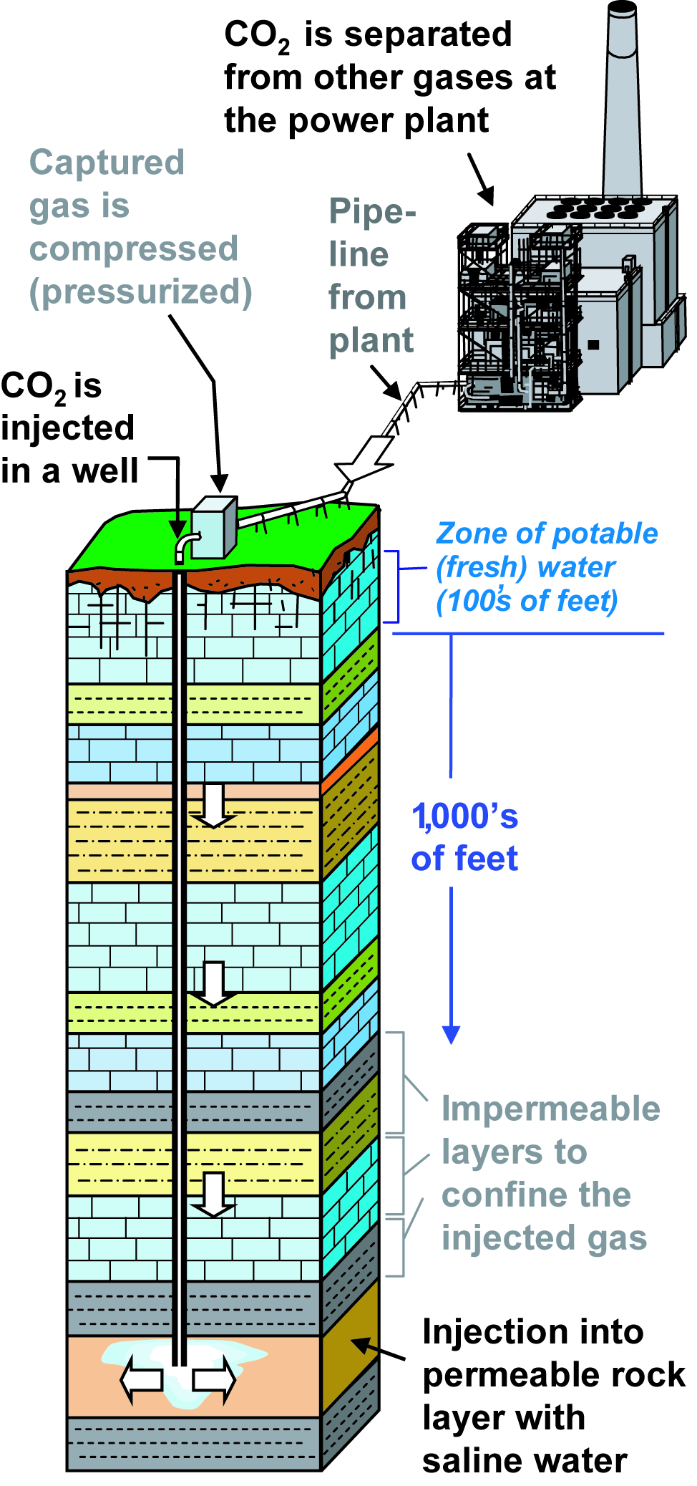
Carbon management involves capture, transport, and storage of carbon dioxide (illustration courtesy of Steve Greb, used by permission of artist).

